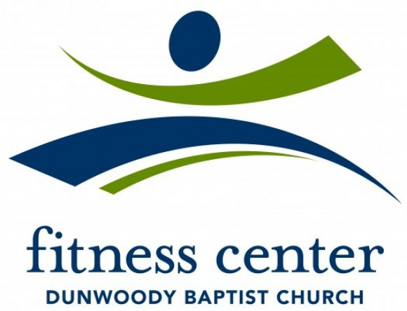
Dear Fitness Center Members,

Beginning on May 3, 2021, we will move into Phase 3 of our reopening.
Hours of Operation
Monday-Friday: 5:30am-8:00pm
Saturday: 8:00am-4:00pm
Check-in
- All members will need to sanitize your hands after entering the building.
- If you have had any of the symptoms in the past 24 hours-fever of 100.4 or higher, cough, chills, headache, shortness of breath, sore throat, new loss of taste or smell, muscle pain-we ask that you please stay home for the health and safety of our DBC family.
While in Facility
- We ask that you wear a mask while not actively working out in the facility.
- Please sanitize the equipment before and after each use. Signs are posted to encourage this.
- Please maintain social distance while in the facility.
Group Fitness
- The Group Fitness Schedule is located on the website. Classes will be added back over time.
- Classes will be held in the basketball gym, outside or group fitness studios.
Pool
- One member or family per lane at a time. Please call ahead to confirm a lane is available.
- The pool will be closed during the Aqua Aerobics class times. Those class times are Monday and Wednesday at 10:00am.
Locker Rooms
- A mask is required at all times while in the locker room unless utilizing the shower.
- The sauna and whirlpool are open. Please call ahead to reserve a time.
- Please limit your amount of time in the locker rooms.
Remember to Bring
- Face Mask
- Towel
- Water Fountains are bottle fill only

Please note, all communication is being posted on our website. Please check often for new updates.

Be Well,
Kyle Roberts

